Digital Image Processing Lab
Dept. of Computer Science & Engineering
University of Rajshahi
DEPARTMENT OF COMPUTER SCIENCE & ENGINEERING

UNIVERSITY OF RAJSHAHI, RAJSHAHI

Part-IV, Semester I
CSE 4182 (Digital Image Processing Lab)

Experiment List:

S/N | Name of the Experiment
01 | Write program to read and display digital image.
02 | Write a program to perform zooming and shrinking an image.
03 | Write a program to perform convolution operation for 1D and 2D data.
04 | To write and execute programs for image arithmetic operations.
05 | Write a program for histogram calculation and equalization.
06 | Write and execute programs to remove noise using spatial filters.
07 | Write and execute programs for image frequency domain filtering.
08 | Write a program for edge detection using different operators.
09 | Write and execute program for image morphological operations erosion and dilation.
10 | To understand various image noise models and to write programs for image restoration
11 | Write a program to perform conversion between color spaces.

Evaluation Process:

S/N | Evaluation Criteria | Mode | Marks (%)
1 | Understanding of the given problem | Viva/voce | 15
2 | Coding and Execution | Code writing | 50
3 | User Interface | Observation | 15
4 | Explanation of the code | Viva/voce | 20

Laboratory Notes:

- Students have to keep separate laboratory note book for this lab.
- They have to note down on note successful code of the day and get respective teacher’s signature of their notebooks.
- They have note down the explanation any error/mistake(s) found during the compilation of their code.

Further Studies and References:
Title:Read and display digital image
Objective:The objective of this lab is to understand how to read and display images using MATLAB.
Outline and Task
Using a web browser, go to the homepage of the course book at http://www.imageprocessingplace.com/and download the \Standard" test images (a set of images found frequently in the literature:Lena, peppers, cameraman, lake, etc.). Try out the basic MATLAB functions for loading,saving, displaying and manipulating digital images on the test images. A few test images canalso be found on the course web page.
Try also the following example, using functions from the Image Processing toolbox, onimages from the course Web page:
% load color image and display it
I = imread('mandrill.tif');
% convert it to an intensity image (gray scale)
I = rgb2gray(I);
% take some image rows: 8, 64, and 128
row8 = I(8,:); row64 = I(64,:); row128 = I(128,:);
% plot something
figure;
subplot(4, 1, 1); imshow(I); title('Image'); axis image tight on;
subplot(4, 1, 2); plot(row8); title('Row 8'); axis tight;
subplot(4, 1, 3); plot(row64); title('Row 64'); axis tight;
subplot(4, 1, 4); plot(row128); title('Row 128'); axis tight;
Mode of Evaluation: Experiment Percentage of Weight:0%

Title:Zooming and Shrinking.

Objective:The objective of this lab is to understand how to Zooming and Shrinking images.

Outline
Zooming:Increasing the number of pixels in an image so that the image appears larger
- Pixel replication--to repeat rows and columns of an image
Image shrinking:By subsampling (produce 1 pixel using 2X2 pixel)
Task:
- Perform zooming and shrinking an image
Mode of Evaluation: Experiment + Viva Percentage of Weight: 0%

Title:Convolution

Objective:The objective of this lab is to understand to implement convolution operation.

Outline
For 1D
Let m = length(u) and n = length(v) . Then w is the vector of length m+n-1 whose kth element is
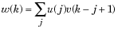
For 2D
If a and b are functions of two discrete variables, n₁ and n₂, then the formula for the two-dimensional convolution of a and b is
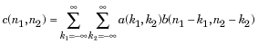

Take value of X: [ 1 2 3 4 5 6 7 8 9 0 10 11 12 13 14 15] and Y: [-1 1].
Enter following 2D matrix for X:
10 10 10 1010 10 10 10
10 10 10 1010 10 10 10
10 10 10 1010 10 10 10
10 10 10 1010 10 10 10
10 10 10 1010 10 10 10
10 10 10 1010 10 10 10
10 10 10 1010 10 10 10
10 10 10 1010 10 10 10
Enter following 2D matrix for Y:
-1-1-1
0 0 0
1 1 1
Task
  - Perform convolution operation in 1D and 2D

Mode of Evaluation: Experiment+Viva Percentage of Weight:0%
Title:Image arithmetic operations
Objective:The objective of this lab is to understand different arithmetic operation.
Outline
Introduction: Arithmetic operations like image addition, subtraction, multiplication and division is possible. If there is two images I1 and I2 then addition of image can be given by:
I(x,y) = I1(x,y) + I2(x,y)
Where I(x,y) is resultant image due to addition of two images, x and y arecoordinates of image. Image addition is pixel to pixel. Value of pixel should not cross maximum allowed value that is 255 for 8 bit grey scale image. When it exceeds value 255, it should be clipped to 255.
To increase overall brightness of the image, we can add some constant value depending on brightness required. In example program we will add value 50 to the image and compare brightness of original and modified image.To decrease brightness of image, we can subtract constant value. In example program, value 100 is subtracted for every pixel. Care should be taken that pixel value should not less than 0 (minus value). Subtract operation can be used to obtain complement (negative) image in which every pixel is subtracted from maximum value i.e. 255 for 8 bit grayscale image.Multiplication operation can be used to mask the image for obtaining region of interest. Black and white mask (binary image) containing 1s and 0s is multiplied with image to get resultant image. To obtain binary imagefunction im2bw() can be used. Multiplication operation can also be used to increase brightness of the imageDivision operation results into floating point numbers. So data type required is floating point numbers. It can be converted into integer data type while storing the image. Division can be used to decrease the brightness of the image. It can also be used to detect change in image.
Task
  - Write MATLAB code that reads a gray-level image
  - Perform arithmetic operations like image negative, addition, subtraction, multiplication and division.
  - After performing the arithmetic operation rescale the image in 8 bit gray-level image.

Mode of Evaluation: Experiment+Viva Percentage of Weight:0%

Title:Histogram
Objective:The objective of this lab is to understand to calculate and plot histogram.
Outline
Image histograms are a simple but very useful method to analyze images and to enhance thequality of the image (at least for a human observer) by performing point transformations.
- Histogram equalization:
- 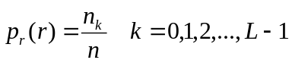The probability of occurrence of gray level r_{k} in an image is

n : the total number of pixels in the image
n_{k} : the number of pixels that have gray levelr_{k}
L : the total number of possible gray levels in the image
- 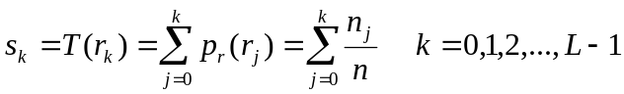The transformation function is

- Thus, an output image is obtained by mapping each pixel with level r_{k} in the input image into a corresponding pixel with level s_{k}.
Task
  - Write MATLAB code that reads a gray-level image
  - Calculate and draw the histogram.
  - Perform equalization and show the output image.

Mode of Evaluation: Experiment+Viva Percentage of Weight:0%

Title:Spatial domain filtering

Objective:The objective of this lab is to understand about contrast mapping, local enhancement and spatial domain filtering.
Outline

Contrast Mapping
An image has a max value of 12000. Its minimum is -3200.
Display it using values 0 - 255.
Give equation needed to rescale it appropriately.
y = [( x - min ) / (max - min)] *255
Or,
y = [(x + 3200) / 15200 ]*255

Local Enhancement
- When it is necessary to enhance details over smaller areas.
- To devise transformation functions based on the gray-level distribution in the neighborhood of every pixel.
- Define a square (or rectangular) neighborhood and move the center of this area from pixel to pixel.
- At each location, the histogram of the points in the neighborhood is computed and either a histogram equalization or histogram specification transformation function is obtained.
- This function is finally used to map the gray level of the pixel centered in the neighborhood.
- The center is then moved to an adjacent pixel location and the procedure is repeated.

Spatial Filtering
- Use of spatial masks for image processing (spatial filters)
- Low-pass filters eliminate or attenuate high frequency components in the frequency domain (sharp image details), and result in image blurring.
- High-pass filters attenuate or eliminate low-frequency components (resulting in sharpening edges and other sharp details).
- Band-pass filters remove selected frequency regions between low and high frequencies (for image restoration, not enhancement).
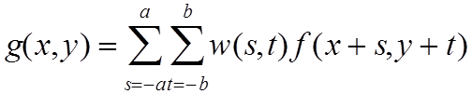
a=(m-1)/2 and b=(n-1)/2,
m x n (odd numbers)
- For x=0,1,…,M-1 and y=0,1,…,N-1
- Also called convolution (primarily in the frequency domain)
- 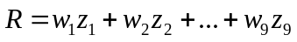The basic approach is to sum products between the mask coefficients and the intensities of the pixels under the mask at a specific location in the image:

(for a 3 x 3 filter)

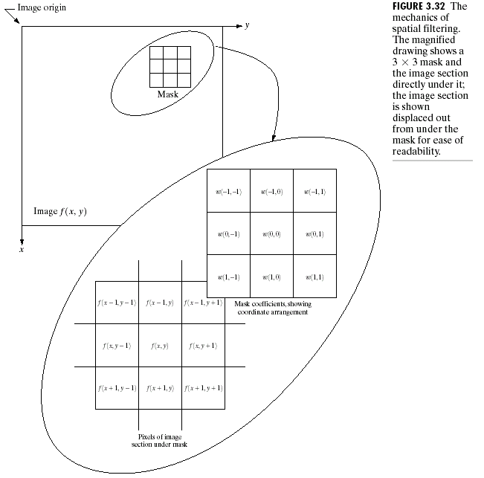
Smoothing Filters
- Used for blurring (removal of small details prior to large object extraction, bridging small gaps in lines) and noise reduction.
- Low-pass (smoothing) spatial filtering
- Neighborhood averaging
- Results in image blurring
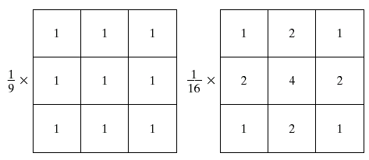
- Median filtering (nonlinear)
- Used primarily for noise reduction (eliminates isolated spikes).
- The gray level of each pixel is replaced by the median of the gray levels in the neighborhood of that pixel (instead of by the average as before).
- Mean Filter
- Used for removal (or reduction) of small (irrelevant) details in image.
- Every pixel replaced by average of its neighbors
Task
  - Write MATLAB code that reads a gray-level image
  - Perform local enhancement
  - Perform smoothing spatial filtering, Median filtering and mean filtering
  - Display the input and output images with histogram

Mode of Evaluation: Experiment+Viva Percentage of Weight:0%
Title:Frequency domain filtering.
Objective:The objective of this lab is to understand about different low-pass and high-pass filtering.
Outline
- Here are some ideas of things can do using frequency domain filtering:
- Smoothing (easy): Truncate high frequencies, keeping the low frequencies. This is called a Low-Pass Filter.
- Edge detection (easy): If only keeping the low frequencies discards the edges of the image, then attenuating the low frequencies should only keep the edges. This is exactly what we find when we apply the above high-pass filter to theimage.
- Instead of talking about one dimensional signals that represent changes in amplitude in time, here we are dealing with two dimensional signals which represent intensity variations in space. These signals come in the form of images. The images we will deal with here are digital, and thus have a finite width and height in pixels, which we will assume have a real number value. Because our signals are discrete, we will need an analog of the one dimensional DFT for two dimensional signals. This analog is the following pair oftransforms:
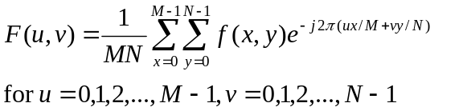

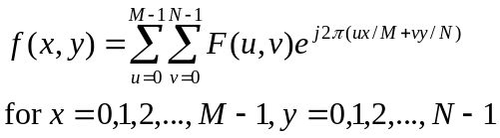

Task
  - Implement either a two-dimensional DFT (simpler to code, butslower) or a two-dimensional FFT (harder to code, but faster) without using Matlab function.
  - Once you implementyour DFT, you should applydifferent lowpass and higpass filtering function in the frequency domain, and then perform theinverse transform to convert back to the spatial domain.
  - Display the input, output, DFT and filter function images.
Mode of Evaluation: Experiment+Viva Percentage of Weight:0%

Title:Edge detection
Objective:The objective of this lab is to understand about different edge detection operator like Sobel, Prewitt, Robel, etc. and Canny edge detection algorithm.
Outline
Edge detection is a terminology in image processing and computer vision, particularly in the areas of feature detection and feature extraction, to refer to algorithms which aim at identifying points in a digital image at which the image brightness changes sharply or more formally has discontinuities. The extraction of edges or contours from a two dimensional array of pixels (a gray-scale image) is a critical step in many image processing techniques. A variety of computations are available which determine the magnitude of contrast changes and their orientation.
There are many ways to perform edge detection. However, the majority of different methods may be grouped into two categories:

- Gradient: The gradient method detects the edges by looking for the maximum and minimum in the first derivative of the image.

- Laplacian: The Laplacian method searches for zero crossings in the second derivative of the image to find edges. An edge has the one-dimensional shape of a ramp and calculating the derivative of the image can highlight its location. Suppose we have the following signal, with an edge shown by the jump in intensity below:

Sobel Operator:

The Sobel operator performs a 2-D spatial gradient measurement on an image and so emphasizes regions of high spatial frequency that correspond to edges. Typically it is used to find the approximate absolute gradient magnitude at each point in an input grayscale image.
Mathematically, the operator uses two 3×3 kernels which are convolved with the original image to calculate approximations of the derivatives - one for horizontal changes, and one for vertical. If we define A as the source image, and Gx and Gy are two images which at each point contain the horizontal and vertical derivative approximations, the computations are as follows:
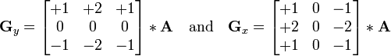
where * here denotes the 2-dimensional convolution operation.
Prewitt Operator:
Mathematically, the operator uses two 3×3 kernels which are convolved with the original image to calculate approximations of the derivatives - one for horizontal changes, and one for vertical. If we define as the source image, and and are two images which at each point contain the horizontal and vertical derivative approximations, the latter are computed as:
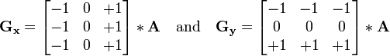
Robel operator:
The Roberts Cross operator performs a simple, quick to compute, 2-D spatial gradient measurement on an image. It thus highlights regions of high spatial frequency which often correspond to edges. In its most common usage, the input to the operator is a grayscale image, as is the output. Pixel values at each point in the output represent the estimated absolute magnitude of the spatial gradient of the input image at that point.
In computer vision, the Roberts' Cross operator is one of the earliest edge detection algorithms, which works by computing the sum of the squares of the differences between diagonally adjacent pixels. This can be accomplished by convolving the image with two 2x2 kernels:
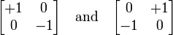

Laplacian of Gaussian:
The Laplacian is a 2-D isotropic measure of the 2nd spatial derivative of an image. The Laplacian of an image highlights regions of rapid intensity change and is therefore often used for edge detection. The Laplacian is often applied to an image that has first been smoothed with something approximating a Gaussian Smoothing filter in order to reduce its sensitivity to noise. The operator normally takes a single graylevel image as input and produces another graylevel image as output.
The LaplacianL(x,y) of an image with pixel intensity values I(x,y) is given by:
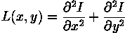
Since the input image is represented as a set of discrete pixels, we have to find a discrete convolution kernel that can approximate the second derivatives in the definition of the Laplacian. Three commonly used small kernels are shown.
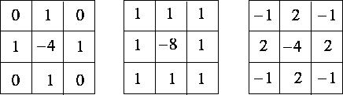
Because these kernels are approximating a second derivative measurement on the image, they are very sensitive to noise. To counter this, the image is often Gaussian Smoothed before applying the Laplacian filter. This pre-processing step reduces the high frequency noise components prior to the differentiation step.
In fact, since the convolution operation is associative, we can convolve the Gaussian smoothing filter with the Laplacian filter first of all, and then convolve this hybrid filter with the image to achieve the required result. Doing things this way has two advantages:
- Since both the Gaussian and the Laplacian kernels are usually much smaller than the image, this method usually requires far fewer arithmetic operations.
- The LoG (`Laplacian of Gaussian') kernel can be pre-calculated in advance so only one convolution needs to be performed at run-time on the image.
Canny’s Edge Detection Algorithm
Canny’s approach is based on three basic objectives:
1. Low error rate. All edges should be found, and there should be no spurious responses. That is, the edges detected must be as close as possible to the true edges.
2. Edge points should be well localized. The edges located must be as close as possible to the true edges. That is, the distances between a point marked as an edge by the detector and the center of the true edge should be minimum.
3. Single edge point response. The detector should return only one point for each true edge point. That is, the number of local maxima around the true edge should be minimum. This means that the detector should not identify multiple edge pixels where only a single edge point exists.
Based on these criteria, the canny edge detector first smoothes the image to eliminate and noise. It then finds the image gradient to highlight regions with high spatial derivatives. The algorithm then tracks along these regions and suppresses any pixel that is not at the maximum (nonmaximum suppression). The gradient array is now further reduced by hysteresis. Hysteresis is used to track along the remaining pixels that have not been suppressed. Hysteresis uses two thresholds and if the magnitude is below the first threshold, it is set to zero (made a nonedge). If the magnitude is above the high threshold, it is made an edge. And if the magnitude is between the 2 thresholds, then it is set to zero unless there is a path from this pixel to a pixel with a gradient above T2.
Step 1
In order to implement the canny edge detector algorithm, a series of steps must be followed. The first step is to filter out any noise in the original image before trying to locate and detect any edges. And because the Gaussian filter can be computed using a simple mask, it is used exclusively in the Canny algorithm. Once a suitable mask has been calculated, the Gaussian smoothing can be performed using standard convolution methods. A convolution mask is usually much smaller than the actual image. As a result, the mask is slide over the image, manipulating a square of pixels at a time. The larger the width of the Gaussian mask, the lower is the detector's sensitivity to noise. The localization error in the detected edges also increases slightly as the Gaussian width is increased. The Gaussian mask used in my implementation is shown below.
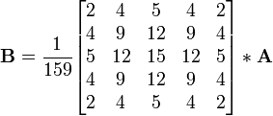
Step 2
After smoothing the image and eliminating the noise, the next step is to find the edge strength by taking the gradient of the image. The Sobel operator performs a 2-D spatial gradient measurement on an image. Then, the approximate absolute gradient magnitude (edge strength) at each point can be found. The Sobel operator uses a pair of 3x3 convolution masks, one estimating the gradient in the x-direction (columns) and the other estimating the gradient in the y-direction (rows). They are shown below:
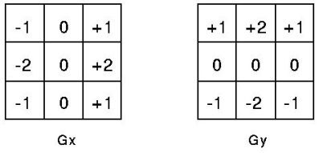
The magnitude, or edge strength, of the gradient is then approximated using the formula:
|G| = |Gx| + |Gy|
Step 3
The direction of the edge is computed using the. However gradient in the x and y directions, an error will be generated when sumX is equal to zero. So in the code there has to be a restriction set whenever this takes place. Whenever the gradient in the x direction is equal to zero, the edge direction has to be equal to 90 degrees or 0 degrees, depending on what the value of the gradient in the y-direction is equal to. If GY has a value of zero, the edge direction will equal 0 degrees. Otherwise the edge direction will equal 90 degrees. The formula for finding the edge direction is just:
Theta = invtan (Gy / Gx)
Step 4
Once the edge direction is known, the next step is to relate the edge direction to a direction that can be traced in an image. So if the pixels of a 5x5 image are aligned as follows:

x x x x x
x x x x x
x x a x x
x x x x x
x x x x x

Then, it can be seen by looking at pixel "a", there are only four possible directions when describing the surrounding pixels - 0 degrees (in the horizontal direction), 45 degrees (along the positive diagonal), 90 degrees (in the vertical direction), or 135 degrees (along the negative diagonal). So now the edge orientation has to be resolved into one of these four directions depending on which direction it is closest to (e.g. if the orientation angle is found to be 3 degrees, make it zero degrees). Think of this as taking a semicircle and dividing it into 5 regions.
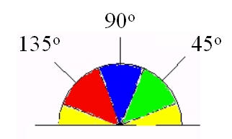
Therefore, any edge direction falling within the yellow range (0 to 22.5 & 157.5 to 180 degrees) is set to 0 degrees. Any edge direction falling in the green range (22.5 to 67.5 degrees) is set to 45 degrees. Any edge direction falling in the blue range (67.5 to 112.5 degrees) is set to 90 degrees. And finally, any edge direction falling within the red range (112.5 to 157.5 degrees) is set to 135 degrees.
Step 5
After the edge directions are known, nonmaximum suppression now has to be applied. Nonmaximum suppression is used to trace along the edge in the edge direction and suppress any pixel value (sets it equal to 0) that is not considered to be an edge. This will give a thin line in the output image.
Step 6
Finally, hysteresis is used as a means of eliminating streaking. Streaking is the breaking up of an edge contour caused by the operator output fluctuating above and below the threshold. If a single threshold, T1 is applied to an image, and an edge has an average strength equal to T1, then due to noise, there will be instances where the edge dips below the threshold. Equally it will also extend above the threshold making an edge look like a dashed line. To avoid this, hysteresis uses 2 thresholds, a high and a low. Any pixel in the image that has a value greater than T1 is presumed to be an edge pixel, and is marked as such immediately. Then, any pixels that are connected to this edge pixel and that have a value greater than T2 are also selected as edge pixels. If you think of following an edge, you need a gradient of T2 to start but you don't stop till you hit a gradient below T1.
Task
- Take a (256×256) or (512×512) 8-bit/pel image and perform the following edge detection operations:
- Sobel Operator
- Prewitt Operator
- Robel operator
- Laplacian of Gaussian
- Canny’s Edge Detection
Mode of Evaluation: Experiment + Viva Percentage of Weight: 0%
Title:Morphological operations
Objective:The objective of this lab is to understand to implement dilation, erosion and other morphological operator.
Outline
- Dilation
- 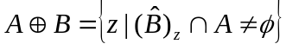With A and B as sets in Z², the dilation of A by B is defined as
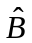
where : the reflection of B about its origin and shifting this reflection by z
- 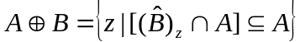The dilation of A by B is the set of all displacements, z, such that and A overlap by at least one element. Thus,

- Set B is referred to as the structuring element in dilation.
- Erosion
- For sets A and B in Z², the erosion of A by B is defined as
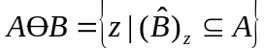
where : the reflection of B about its origin and shifting this reflection by z
- The erosion of A by B is the set of all points z, such that B, translated by z is contained in A.
Task
- Dilate an image
- Erode an Image

Mode of Evaluation: Experiment + Viva Percentage of Weight: 0%

Title:Image restoration.
Objective:The objective of this lab is to understand about different white noise model.
Outline
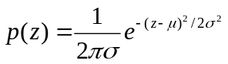Noise cannot be predicted but can be approximately described instatistical way using the probability density function (PDF)
Gaussian noise:
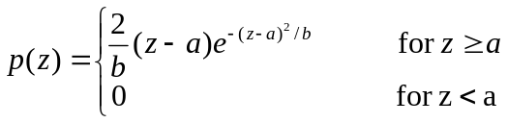
Rayleigh noise:
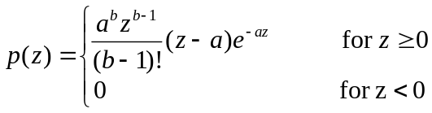
Erlang (Gamma) noise:

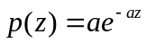Exponential noise:
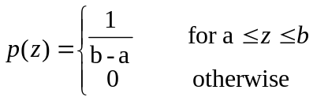
Uniform noise:
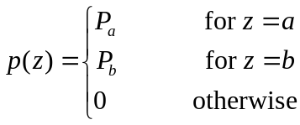
Impulse (salt & pepper) noise:

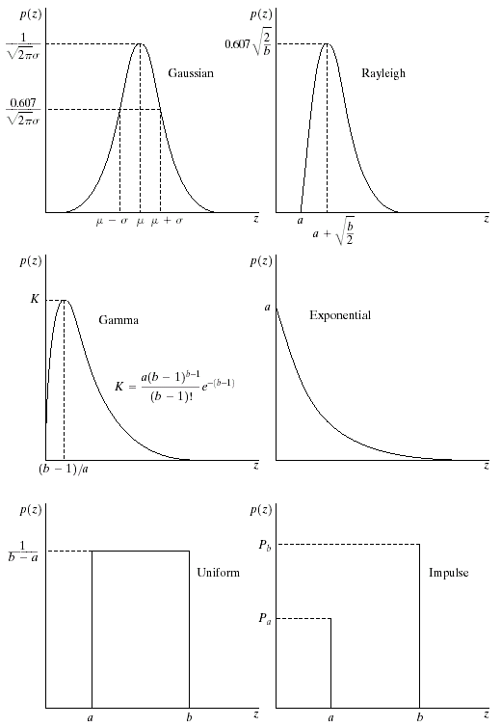
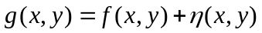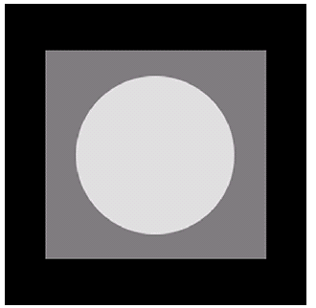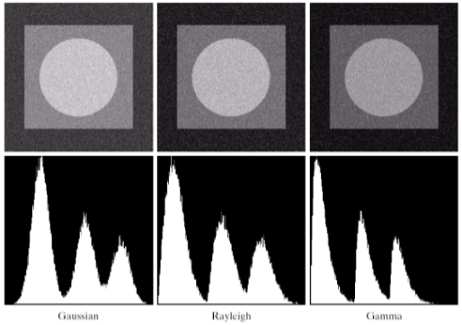
Degraded images

Histogram

Original image
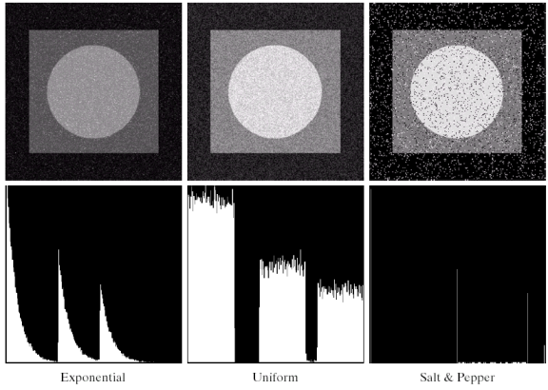
Degraded images

Histogram

Task
  - Load an image without noise
  - Generate different noise images of original image size
  - Add noise image with original image
  - Apply suitable filter to remove the noise
  - Display input and output images with histogram
Mode of Evaluation: Experiment + Viva Percentage of Weight:0%

Title:Color image processing.
Objective:The objective of this lab is to understand to convert CMY, RGB and HIS color model and conversion.
Outline
- CMY to RGB color model
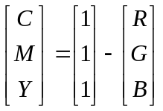

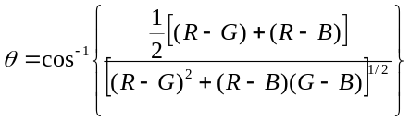
- RGB to HSI color model
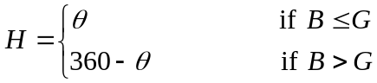
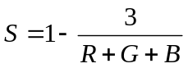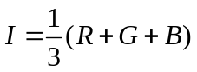

- 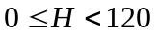HSI to RGB color model
- RG sector:
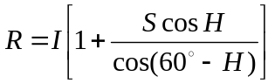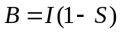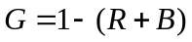

- 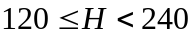GB sector:
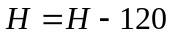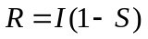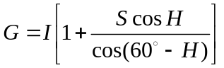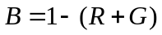

- 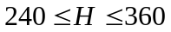BR sector:
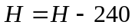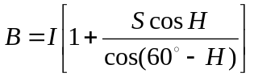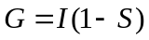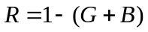

Task
- Convert an image into CMY to RGB color model
- Convert an image into RGB to HSI color model
- Convert an image into
- HSI to RGB color model

Mode of Evaluation: Experiment + Viva Percentage of Weight:0%

Title:Goussian Low pass Filter
clear; clc;
input_image_name = input('input image name = ');
input_image = imread(input_image_name);
subplot(3,2,1); imshow(input_image);
input_image = rgb2gray(input_image);
subplot(3,2,2); imshow(input_image);
[row, column] = size(input_image);

centered_input_image = zeros(row,column);
for x = 1:row
for y = 1:column
centered_input_image(x,y) = double(input_image(x,y))*((-1)^(x+y));
end
end

dft_of_centered_input_image = only_dft(centered_input_image);
subplot(3,2,3); imshow(real(dft_of_centered_input_image));

H = zeros(row,column);
d0 = input('cut-off frequency (d0) = ');
for u = 1:row
for v = 1:column
D = ((u-row/2)^2+(v-column/2)^2)^(1/2);
H(u,v) = exp((-(D^2))/(2*(d0^2)));
end
end
subplot(3,2,4); imshow(H);

filtered_dft = (dft_of_centered_input_image).*(H);

idft_of_filtered_dft = only_idft(filtered_dft);
idft_of_filtered_dft = real(idft_of_filtered_dft);

temp_output_image = zeros(row,column);
for x = 1:row
for y = 1:column
temp_output_image(x,y) = idft_of_filtered_dft(x,y)*((-1)^(x+y));
end
end

output_image = only_normalize(temp_output_image);
subplot(3,2,5); imshow(output_image);
DFT:
functiondft_of_input_image = only_dft(input_image)
[row, column] = size(input_image);
dft_of_input_image = zeros(row,column);
a = waitbar(0,'Calculating DFT, please wait......');
for u = 1:row
for v = 1:column
s = 0.0;
for x = 1:row
for y = 1:column
s = s+double(input_image(x,y))*exp((-1)*(sqrt(-1))*2*pi*((((u-1)*(x-1))/row)+(((v-1)*(y-1))/column)));
end
end
dft_of_input_image(u,v) = s;
end
waitbar((u)/row);
end
close(a);

IDFT:
functionidft_of_input_image = only_idft(dft_of_input_image)
[row, column] = size(dft_of_input_image);
idft_of_input_image = zeros(row,column);
a = waitbar(0,'Calculating inverse DFT, please wait......');
for x = 1:row
for y = 1:column
s = 0.0;
for u = 1:row
for v = 1:column
s = s+dft_of_input_image(u,v)*exp((sqrt(-1))*2*pi*((((u-1)*(x-1))/row)+(((v-1)*(y-1))/column)));
end
end
idft_of_input_image(x,y) = s/(sqrt(row*column));
end
waitbar((x)/row);
end
close(a);

Normalization:
functionnormalized_input_image = only_normalize(input_image)
maximum = max(max(input_image));
minimum = min(min(input_image));
normalized_input_image = uint8(floor(((input_image-minimum)/(maximum-minimum)).*255));

Title: Butterworth High pass Filter

clear; clc;
input_image_name = input('input image name = ');
input_image = imread(input_image_name);
subplot(3,2,1); imshow(input_image);
input_image = rgb2gray(input_image);
subplot(3,2,2); imshow(input_image);
[row, column] = size(input_image);

centered_input_image = zeros(row,column);
for x = 1:row
for y = 1:column
centered_input_image(x,y) = double(input_image(x,y))*((-1)^(x+y));
end
end

dft_of_centered_input_image = only_dft(centered_input_image);
subplot(3,2,3); imshow(real(dft_of_centered_input_image));

H = zeros(row,column);
d0 = input('cut-off frequency (d0) = ');
n = input('order (n) = ');
for u = 1:row
for v = 1:column
D = ((u-row/2)^2+(v-column/2)^2)^(1/2);
H(u,v) = (1/(1+((d0/D)^(2*n))));
end
end
subplot(3,2,4); imshow(H);

filtered_dft = (dft_of_centered_input_image).*(H);

idft_of_filtered_dft = only_idft(filtered_dft);
idft_of_filtered_dft = real(idft_of_filtered_dft);

temp_output_image = zeros(row,column);
for x = 1:row
for y = 1:column
temp_output_image(x,y) = idft_of_filtered_dft(x,y)*((-1)^(x+y));
end
end

output_image = only_normalize(temp_output_image);
subplot(3,2,5); imshow(output_image);

Title: Gaussian High pass Filter

clear; clc;
input_image_name = input('input image name = ');
input_image = imread(input_image_name);
subplot(3,2,1); imshow(input_image);
input_image = rgb2gray(input_image);
subplot(3,2,2); imshow(input_image);
[row, column] = size(input_image);

centered_input_image = zeros(row,column);
for x = 1:row
for y = 1:column
centered_input_image(x,y) = double(input_image(x,y))*((-1)^(x+y));
end
end

dft_of_centered_input_image = only_dft(centered_input_image);
subplot(3,2,3); imshow(real(dft_of_centered_input_image));

H = zeros(row,column);
d0 = input('cut-off frequency (d0) = ');
for u = 1:row
for v = 1:column
D = ((u-row/2)^2+(v-column/2)^2)^(1/2);
H(u,v) = 1-exp((-(D^2))/(2*(d0^2)));
end
end
subplot(3,2,4); imshow(H);

filtered_dft = (dft_of_centered_input_image).*(H);

idft_of_filtered_dft = only_idft(filtered_dft);
idft_of_filtered_dft = real(idft_of_filtered_dft);

temp_output_image = zeros(row,column);
for x = 1:row
for y = 1:column
temp_output_image(x,y) = idft_of_filtered_dft(x,y)*((-1)^(x+y));
end
end

output_image = only_normalize(temp_output_image);
subplot(3,2,5); imshow(output_image);

Title: Butterworth Low pass Filter:

clear; clc;
input_image_name = input('input image name = ');
input_image = imread(input_image_name);
subplot(3,2,1); imshow(input_image);
input_image = rgb2gray(input_image);
subplot(3,2,2); imshow(input_image);
[row, column] = size(input_image);

centered_input_image = zeros(row,column);
for x = 1:row
for y = 1:column
centered_input_image(x,y) = double(input_image(x,y))*((-1)^(x+y));
end
end

dft_of_centered_input_image = only_dft(centered_input_image);
subplot(3,2,3); imshow(real(dft_of_centered_input_image));

H = zeros(row,column);
d0 = input('cut-off frequency (d0) = ');
n = input('order (n) = ');
for u = 1:row
for v = 1:column
D = ((u-row/2)^2+(v-column/2)^2)^(1/2);
H(u,v) = (1/(1+((D/d0)^(2*n))));
end
end
subplot(3,2,4); imshow(H);

filtered_dft = (dft_of_centered_input_image).*(H);

idft_of_filtered_dft = only_idft(filtered_dft);
idft_of_filtered_dft = real(idft_of_filtered_dft);

temp_output_image = zeros(row,column);
for x = 1:row
for y = 1:column
temp_output_image(x,y) = idft_of_filtered_dft(x,y)*((-1)^(x+y));
end
end

output_image = only_normalize(temp_output_image);
subplot(3,2,5); imshow(output_image);

Title: Edge Detection

Laplacian:
clear; clc;
input_image_name = input('input image name = ');
threshold = input('threshold value = ');
input_image = imread(input_image_name);
subplot(1,3,1); imshow(input_image);
input_image = rgb2gray(input_image);
subplot(1,3,2); imshow(input_image);
[row, column] = size(input_image);
result = zeros(row,column);

% mask :
% | 0 -1 0 |
% | -1 4 -1 |
% | 0 -1 0 |
mask = zeros(3,3);
mask(1,2) = (-1);
mask(2,1) = (-1);
mask(2,3) = (-1);
mask(3,2) = (-1);
mask(2,2) = (4);
for i = 2:(row-1)
for j = 2:(column-1)
temp = sum(sum(double(input_image((i-1:i+1),(j-1:j+1))).*mask));
if(abs(temp) >= threshold)
result(i,j) = 255;
end
end
end

subplot(1,3,3); imshow(result);

Prewitt:
clear; clc;
input_image_name = input('input image name = ');
threshold = input('threshold value = ');
input_image = imread(input_image_name);
subplot(1,3,1); imshow(input_image);
input_image = rgb2gray(input_image);
subplot(1,3,2); imshow(input_image);
[row, column] = size(input_image);
result = zeros(row,column);

% horizontal mask :
% | -1 -1 -1 |
% | 0 0 0 |
% | 1 1 1 |
mask = zeros(3,3);
mask(1,1) = (-1);
mask(1,2) = (-1);
mask(1,3) = (-1);
mask(3,1) = (1);
mask(3,2) = (1);
mask(3,3) = (1);
for i = 2:(row-1)
for j = 2:(column-1)
temp = sum(sum(double(input_image((i-1:i+1),(j-1:j+1))).*mask));
if(abs(temp) >= threshold)
result(i,j) = result(i,j)+255;
end
end
end

% positive 45 degree mask :
% | -1 -1 0 |
% | -1 0 1 |
% | 0 1 1 |
mask = zeros(3,3);
mask(1,1) = (-1);
mask(1,2) = (-1);
mask(2,1) = (-1);
mask(2,3) = (1);
mask(3,2) = (1);
mask(3,3) = (1);
for i = 2:(row-1)
for j = 2:(column-1)
temp = sum(sum(double(input_image((i-1:i+1),(j-1:j+1))).*mask));
if(abs(temp) >= threshold)
result(i,j) = result(i,j)+255;
end
end
end

% vertical mask :
% | -1 0 1 |
% | -1 0 1 |
% | -1 0 1 |
mask = zeros(3,3);
mask(1,1) = (-1);
mask(2,1) = (-1);
mask(3,1) = (-1);
mask(1,3) = (1);
mask(2,3) = (1);
mask(3,3) = (1);
for i = 2:(row-1)
for j = 2:(column-1)
temp = sum(sum(double(input_image((i-1:i+1),(j-1:j+1))).*mask));
if(abs(temp) >= threshold)
result(i,j) = result(i,j)+255;
end
end
end

% negative 45 degree mask :
% | 0 1 1 |
% | -1 0 1 |
% | -1 -1 0 |
mask = zeros(3,3);
mask(2,1) = (-1);
mask(3,1) = (-1);
mask(3,2) = (-1);
mask(1,2) = (1);
mask(1,3) = (1);
mask(2,3) = (1);
for i = 2:(row-1)
for j = 2:(column-1)
temp = sum(sum(double(input_image((i-1:i+1),(j-1:j+1))).*mask));
if(abs(temp) >= threshold)
result(i,j) = result(i,j)+255;
end
end
end

for i = 2:(row-1)
for j = 2:(column-1)
if(result(i,j) > 255)
result(i,j) = floor(result(i,j)/4);
end
end
end

subplot(1,3,3); imshow(result);

Title: Point Detection
clear; clc;
input_image_name = input('input image name = ');
threshold = input('threshold value = ');
input_image = imread(input_image_name);
subplot(1,3,1); imshow(input_image);
input_image = rgb2gray(input_image);
subplot(1,3,2); imshow(input_image);
% mask :
% | -1 -1 -1 |
% | -1 8 -1 |
% | -1 -1 -1 |
mask = (-1)*ones(3,3);
mask(2,2) = (8);
[row, column] = size(input_image);
result = zeros(row,column);
for i = 2:(row-1)
for j = 2:(column-1)
temp = sum(sum(double(input_image((i-1:i+1),(j-1:j+1))).*mask));
if(abs(temp) >= threshold)
result(i,j) = 255;
end
end
end
subplot(1,3,3); imshow(result);

Title: Line Detection
clear; clc;
input_image_name = input('input image name = ');
threshold = input('threshold value = ');
input_image = imread(input_image_name);
subplot(1,3,1); imshow(input_image);
input_image = rgb2gray(input_image);
subplot(1,3,2); imshow(input_image);
[row, column] = size(input_image);
result = zeros(row,column);

% horizontal mask :
% | -1 -1 -1 |
% | 2 2 2 |
% | -1 -1 -1 |
mask = (-1)*ones(3,3);
mask(2,1) = (2);
mask(2,2) = (2);
mask(2,3) = (2);
for i = 2:(row-1)
for j = 2:(column-1)
temp = sum(sum(double(input_image((i-1:i+1),(j-1:j+1))).*mask));
if(abs(temp) >= threshold)
result(i,j) = result(i,j)+255;
end
end
end

% positive 45 degree mask :
% | -1 -1 2 |
% | -1 2 -1 |
% | 2 -1 -1 |
mask = (-1)*ones(3,3);
mask(1,3) = (2);
mask(2,2) = (2);
mask(3,1) = (2);
for i = 2:(row-1)
for j = 2:(column-1)
temp = sum(sum(double(input_image((i-1:i+1),(j-1:j+1))).*mask));
if(abs(temp) >= threshold)
result(i,j) = result(i,j)+255;
end
end
end

% vertical mask :
% | -1 2 -1 |
% | -1 2 -1 |
% | -1 2 -1 |
mask = (-1)*ones(3,3);
mask(1,2) = (2);
mask(2,2) = (2);
mask(3,2) = (2);
for i = 2:(row-1)
for j = 2:(column-1)
temp = sum(sum(double(input_image((i-1:i+1),(j-1:j+1))).*mask));
if(abs(temp) >= threshold)
result(i,j) = result(i,j)+255;
end
end
end

% negative 45 degree mask :
% | 2 -1 -1 |
% | -1 2 -1 |
% | -1 -1 2 |
mask = (-1)*ones(3,3);
mask(1,1) = (2);
mask(2,2) = (2);
mask(3,3) = (2);
for i = 2:(row-1)
for j = 2:(column-1)
temp = sum(sum(double(input_image((i-1:i+1),(j-1:j+1))).*mask));
if(abs(temp) >= threshold)
result(i,j) = result(i,j)+255;
end
end
end

for i = 2:(row-1)
for j = 2:(column-1)
if(result(i,j) > 255)
result(i,j) = floor(result(i,j)/4);
end
end
end

subplot(1,3,3); imshow(result);

